**PROJECT**

**INPUT DATASET**

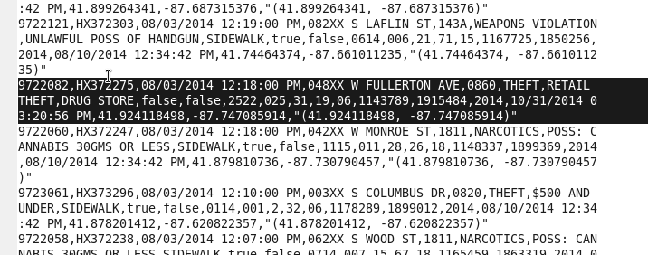

**Q1.Write a mapreduce and pig program to calculate the number of cases investigated under each FBI code**

**MAPREDUCE:**

**PROJECT DRIVER**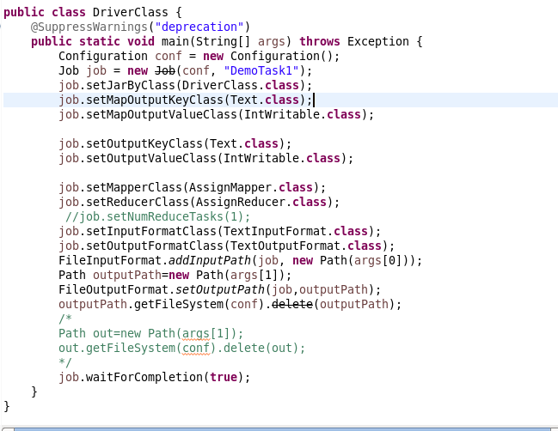

**PROJECT MAPPER**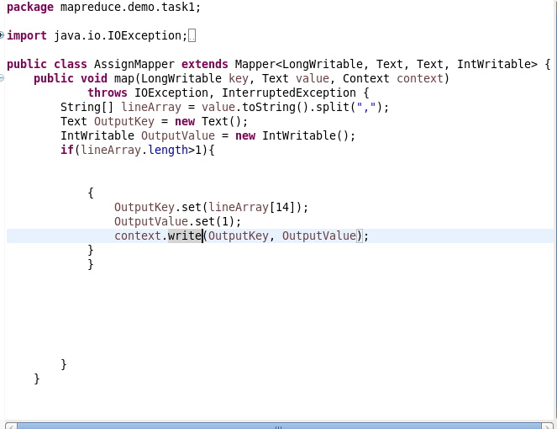

**PROJECT REDUCER**

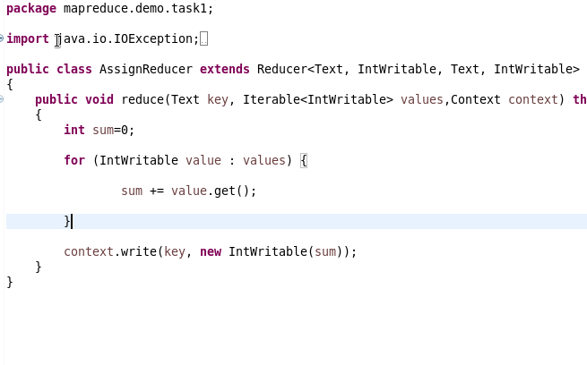

**CREATING A JAR**

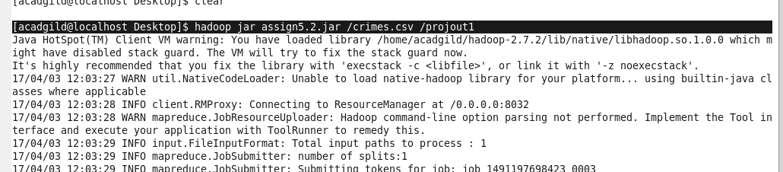

**OUTPUT1**

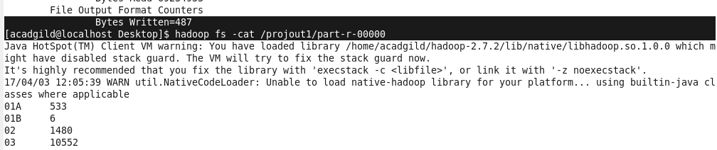

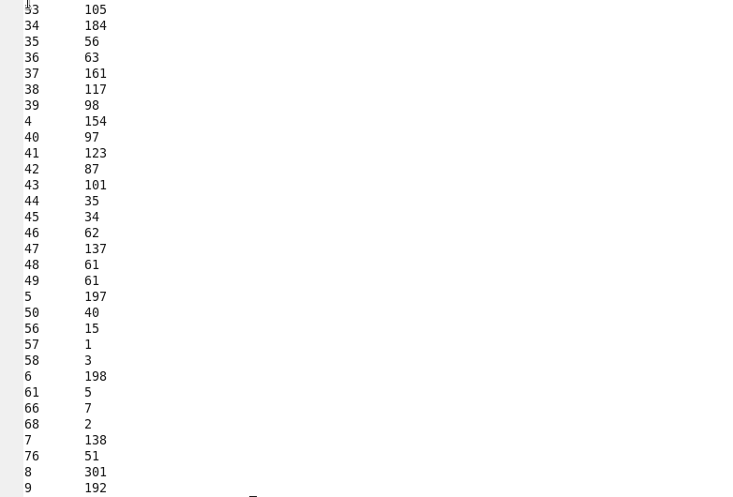

**PIG**

**LOAD DATASET**



**GROUP BY FBICODE**

**C:\Users\612909\Desktop\hadoop\projpiggroupbyfbi.PNG**

**OUTPUT**

**C:\Users\612909\Desktop\hadoop\projpigforeach.PNG**

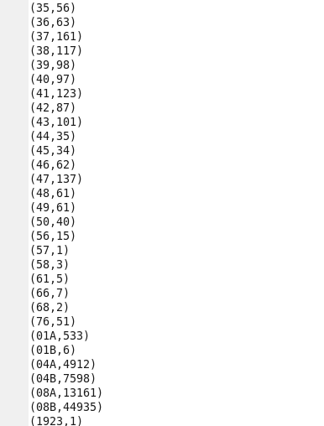

**Q 2. Write a mapreduce and pig program to calculate the number of cases investigated under FBI code 32.**

**MAPREDUCE**

**MAPPER**

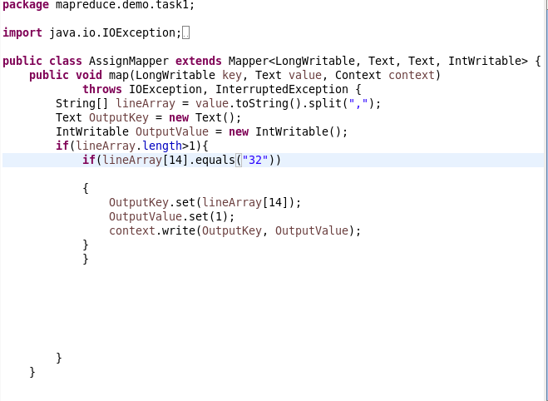

**OUTPUT**



**PIG:**

**Filter fbicode=32**

**Generate count**

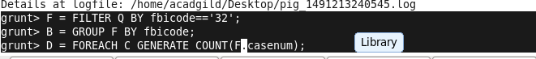

**Output**

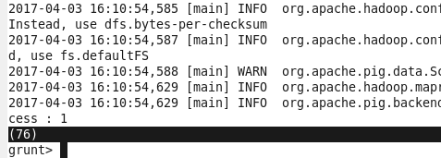

**Q.3 Write a mapreduce and pig program to calculate the number of arrests in theft district wise.**

**MAPREDUCE**

LineArray[5] is Primary type-description of theft(for ex. Car-theft)

LineArray[11] is the name of district



**MAPPER**

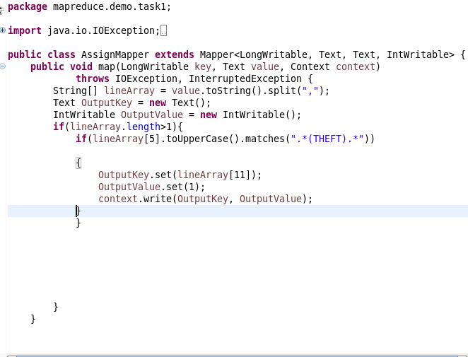

**OUTPUT**

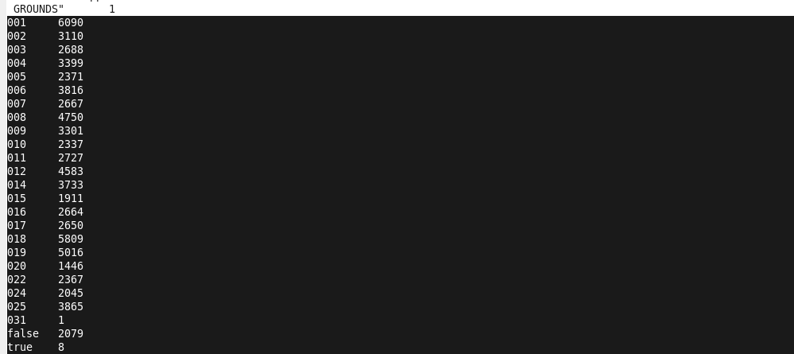

**PIG:**

**FILTER DATASET BY THEFT AND GROUP BY DISTRICT**

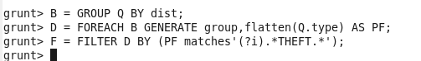

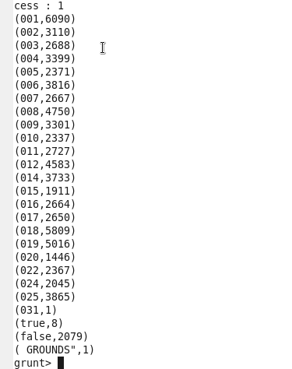

**Q.4 Write a mapreduce and pig program to calculate the number of arrests done between October 2014 and October 2015.**

**MAPREDUCE**

LineArray[18] is Updated on-date

LineArray[5] is arrest(true/false)

**MAPPER**

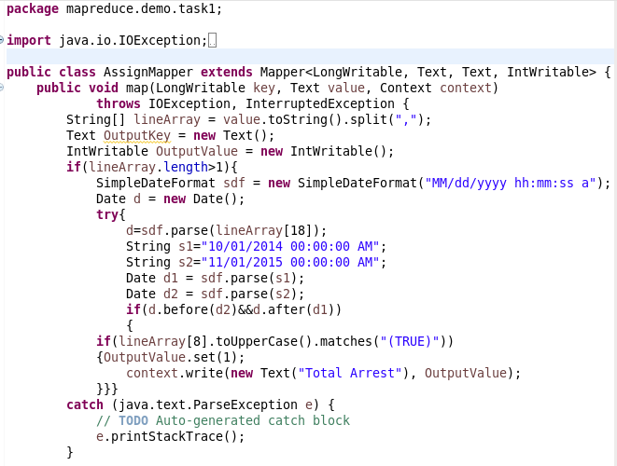

**OUTPUT**

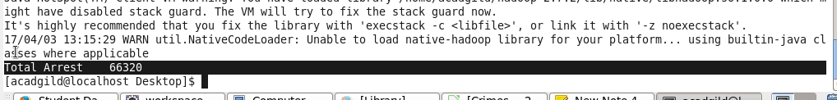

**PIG:**

**Check for arrest and format updated date**

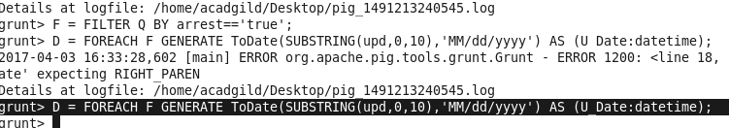

**Find days between october 2014 and october 2015**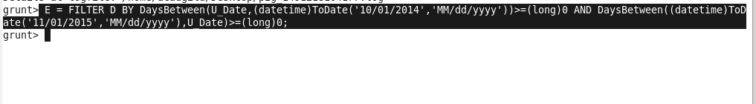

**Output:**

